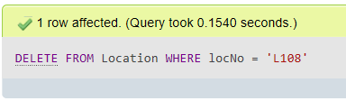

DELETE FROM Location

WHERE locNo = 'L108';